**Financial Chatbot**

**Problem Statement:**

The financial chatbot is built on the financial data of 101 companies. The goal is to help users get relevant information about any financial company and perform some comparative financial analysis between companies in the database.

**Proposed Solution:**

As part of our proposed solution, we will develop a RAG (Retrieve, Augment, Generate) application, which will form the core of our chatbot system. This platform will integrate a Large Language Model (LLM) to generate responses.

The chatbot will accept natural language input from users. The LLM will then determine the necessary SQL (Structured Query Language) operations to execute on the database to retrieve the relevant information. The results will be converted back into natural language for presentation to the user. This approach also facilitates comparative financial analysis of the companies in the database.

We have sourced the quarterly financial data of the companies from Yahoo Finance using the 'yfinance' Python library.

**Models Used:**

Free LLM Models from Groq: Llama 3 8B, Llama 3 70B, mixtral-8x7b, gemma-7b

Paid LLM Model: OpenAI GPT 3.5

The paid LLM model for obvious reasons outperforms in performance the open-sourced LLM models. But the results of the open-source models were also good.

For more information on OpenAI GPT 3.5 refer [here.](https://platform.openai.com/docs/overview)

To learn more about the open-sourced LLM models used refer [Link on LLama3](https://ai.meta.com/blog/meta-llama-3/) , [Mixtral-8x7b](https://docs.mistral.ai/getting-started/models/) and [Hugging Face Gemma](https://huggingface.co/docs/transformers/en/model_doc/gemma) . These open-source models were accessible with the help of [Groq Api Key](https://console.groq.com/keys).

**Database Used:**

Initially the data was collected in a CSV file of all the financial parameters for their respective quarters. Then the entire data of 101 companies was transferred to SQLite database for the ease of performing SQL operations.

SQLite is a lightweight, serverless database that requires zero configuration, making it easy to set up and maintain. It stores data in a single, portable file, ensuring simple file management and reliable backups. With ACID compliance and robust crash recovery, SQLite offers reliable transaction processing. Additionally, it excels in read-heavy workloads and can be configured for fast in-memory operations, making it ideal for embedded systems and resource-limited applications.

For further information please refer [here.](https://www.sqlite.org/docs.html)

**Results:**

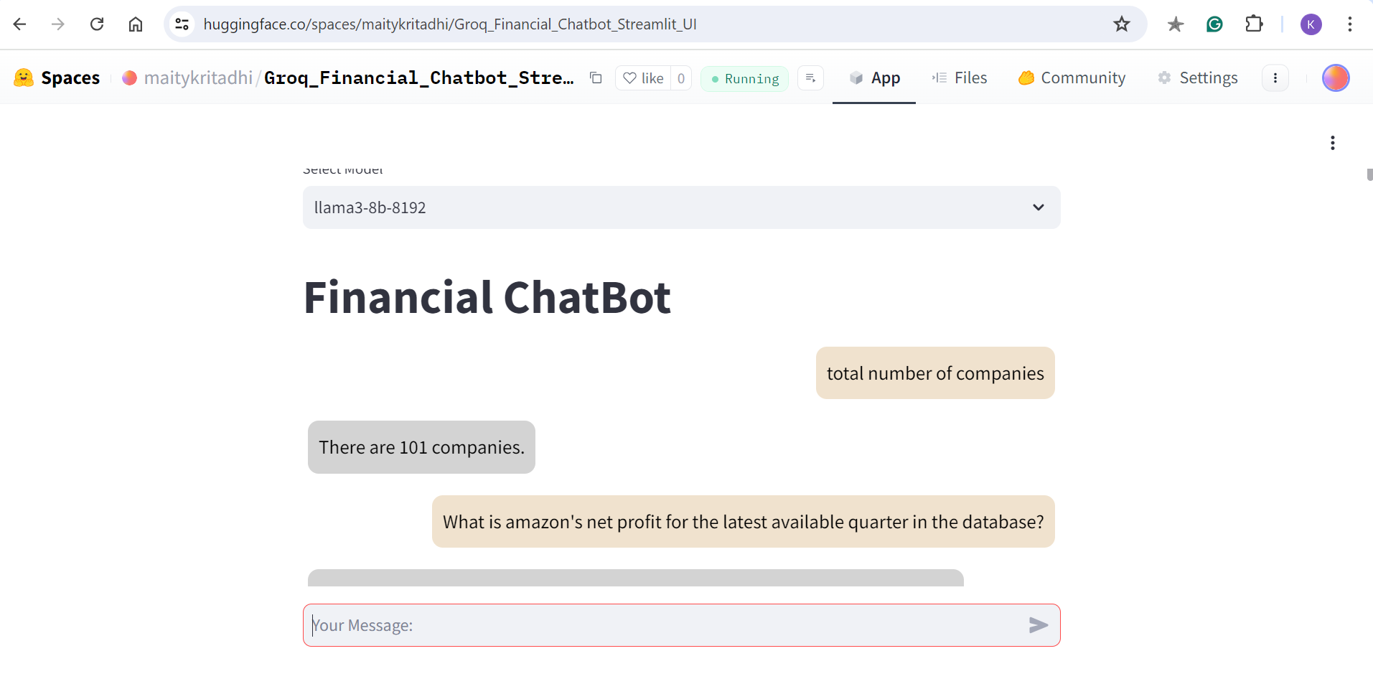

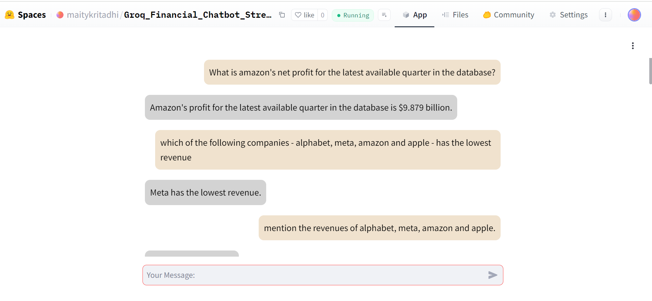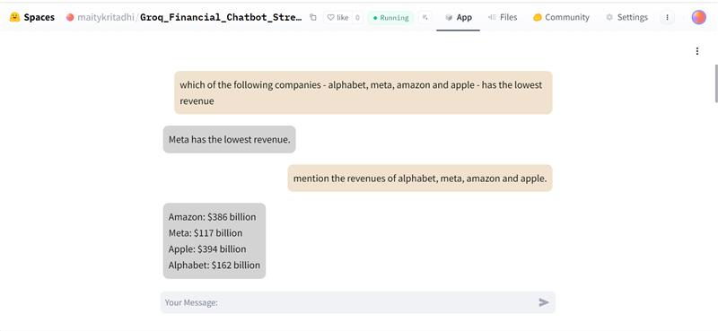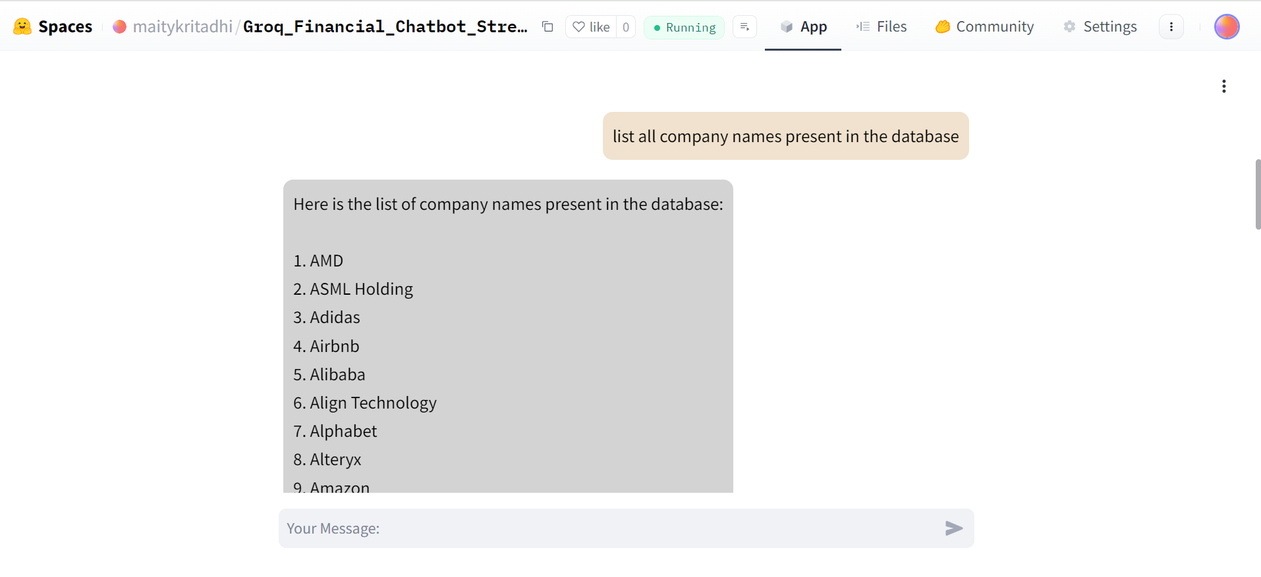

The chatbot is currently deployed on Hugging Face Spaces. Below are the deployed links attached.

1. [OpenAI Finance Bot Deployed Link](https://huggingface.co/spaces/maitykritadhi/Kr_Financial_Chatbot_StreamLitUI) - Paid OpenAI LLM is used
2. [Groq Finance Chatbot Deployed Link](https://huggingface.co/spaces/maitykritadhi/Groq_Financial_Chatbot_Streamlit_UI) - Open-source LLM models used

Code Repository: [Hugging Face Code Repository](https://huggingface.co/spaces/maitykritadhi/Groq_Financial_Chatbot_Streamlit_UI/tree/main)